Patient Quit Plan and Resources

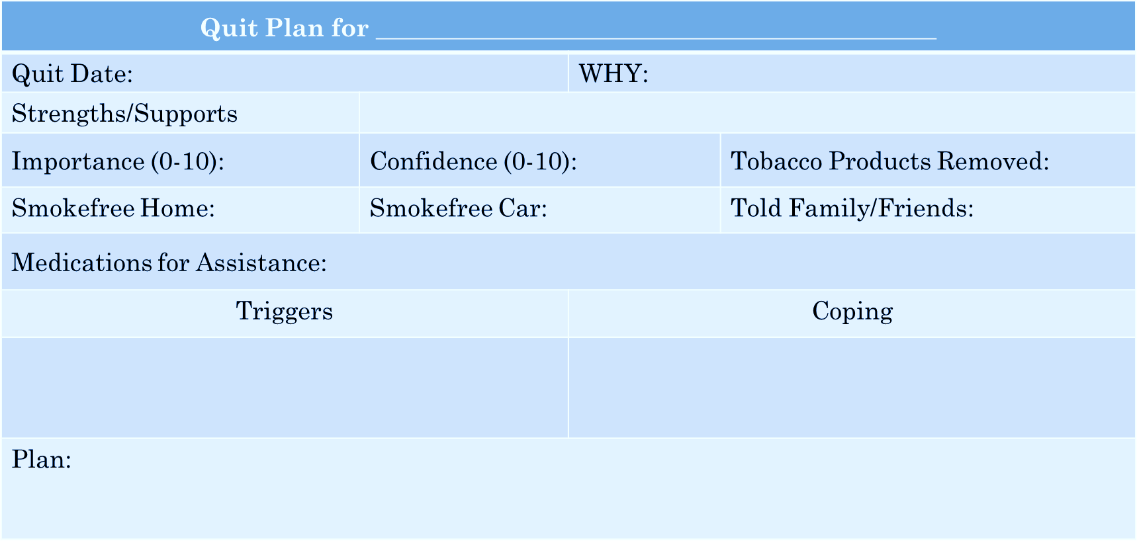

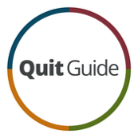

**Websites**

<https://smokefree.gov/>

<https://women.smokefree.gov/>

<https://women.smokefree.gov/pregnancy-motherhood>

<https://www.cdc.gov/tobacco/quit_smoking/how_to_quit/index.htm>

<https://truthinitiative.org/research-resources>

**quitSTART App**

Free, available on Google Play and Apple Store

Provides tailored tips, inspiration, and challenges

Monitors progress and helps with managing cravings

**QuitGuide App**

Free, available on Google Play and Apple Store

Tracks cravings and triggers

Provides tips and inspiration

Monitor progress and allows journaling

**1-800-QUIT-NOW**

Phone + Online, Online only, Phone only

Mon-Sun 7AM-1AM EST

Personalized coaching, development of quit plan, progress tracking

Assistance with medications

Opt-in program for pregnant and postpartum women that offers incentives

**SmokefreeMOM**

Mobile texting program

Provides 24/7 tips, advice, and encouragement to help pregnant women who want to quit smoking

Text MOM to 222888

Receive 3-6 text messages per day

Lasts at least 6 weeks, but depends on due date